Aramex Shopify Shipping Application User Manual
Last updated on: March 2014

Thank you for using our Aramex Shopify Shipping App. We provide this Manual that will cover all the features and options you need to kick off your orders using our app.
Aramex Shopify Features:
Aramex Shopify app provides the below features, a small description is listed below, and will go through each one in details:
- Prepare Shipment : this feature will allow users to create shipments for their orders, to be shipped by Aramex
- Print Label: get an Aramex label with the shipment details
- Schedule Pickup: submit a request for Aramex to pick up your shipment
- Track Shipment: get the current status of shipments along with history of updates and locations
- Calculate Rate: this feature allows users to check Rates between origins and destinations
Aramex Global Settings
After getting the app, you will need to set the account and shipper details, you can do it by following the below steps:
- You need to be registered on aramex.com to use this App, if you have any problem with signing up to aramex.com please check the Aramex.com User Manual to help you register on aramex.com.
- Once your account is ready on aramex.com, you will have to configure the account settings on the App, by filling the username and password of the account, and the Account details.
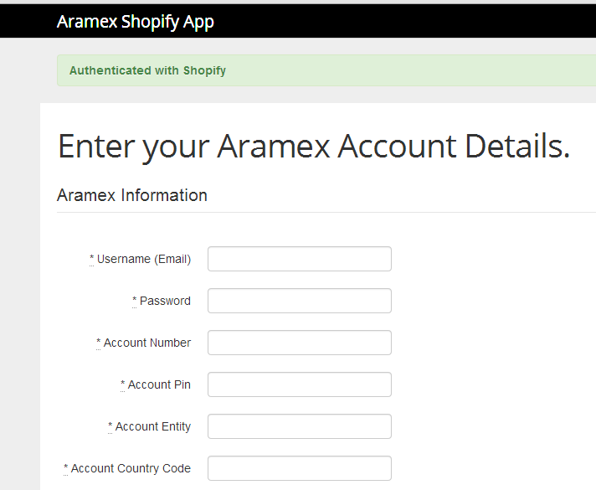
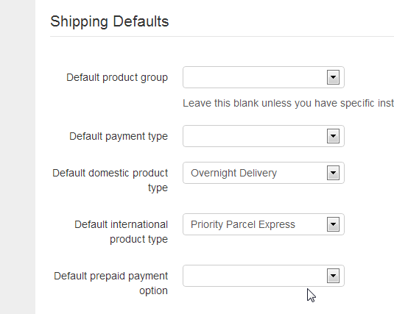

Shopify Order Page:
- Upon creating an order from the shopping website, this order will be accessible through the Shopify Admin Panel in order to proceed with preparing a shipment.

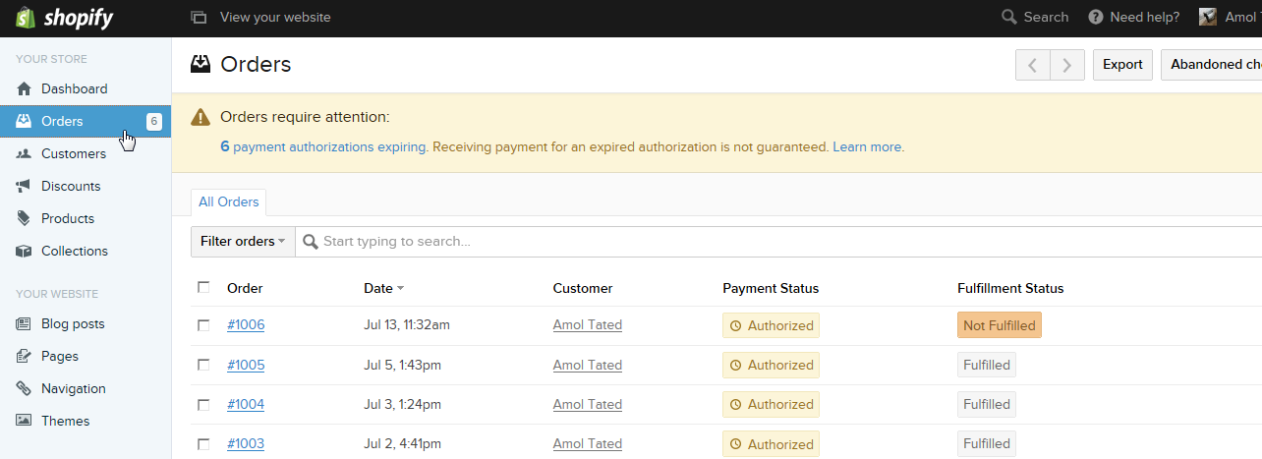

- This page will show both fulfilled and not fulfilled orders (Fulfilled orders are already processed and completed, while the Not Fulfilled is not yet processed through Aramex.
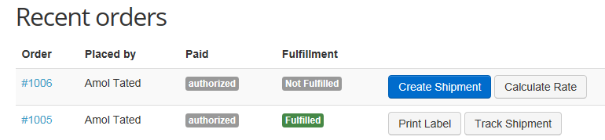

- Calculate Rate
Upon opening the Order page, for Not Fulfilled orders, you will find the options that can be done for this order as shown below, Using the Calculate Rate, users can check their shipping rates by selecting the origin and destination, and rates will be deferent from Account to another as each account has its own rate sheet.
- Click on calculate rate button, Fill necessary information related to the origin and destination countries, product types, and weight, and then click on calculate rate.
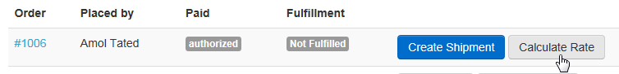
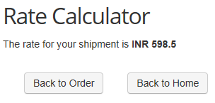

- Schedule Pickup
By this functionality you can arrange pickup from different location and you will get collection reference number in response.
- Users can access this page by clicking on the (Create Shipment Icon) and then click on (schedule a Pickup Icon.
- Note: You can schedule pickup before preparing shipment. This is optional functionality which can be used for different location pickup instead of regular pickup location.
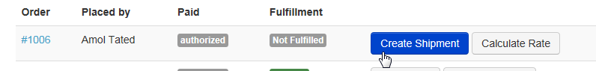
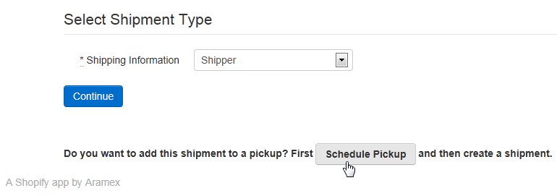
- Fill all the required fields that are divided into (Pickup Details and Pickup Address Information) and then click on Create Pickup to get the Pickup number.
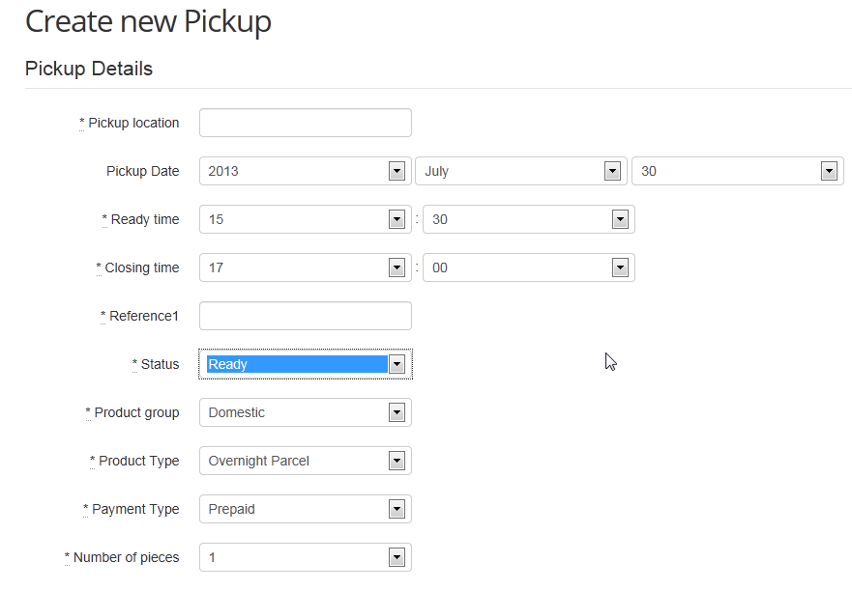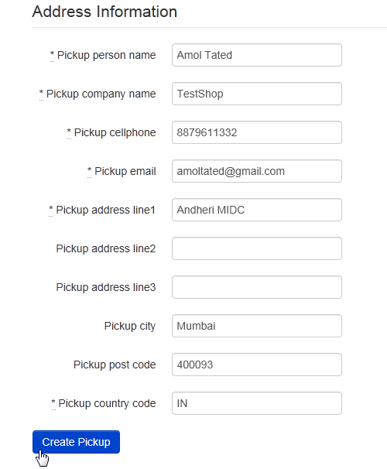

- Prepare Shipment
This function will allow users to create Shipments to be saved in Aramex System, this shipment Number (AWB Number) can be tracked through the App or by tracking it on www.aramex.com.
To create a shipment please follow the below steps:

- Click on Create shipment from the orders page.
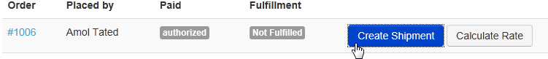
- Select Shipping Information and click on continue. The Shipper Information will be selceted as default.
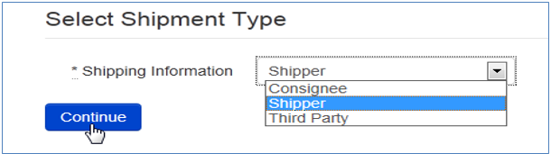
- The Shipper information will be automatically filled from the default account information.
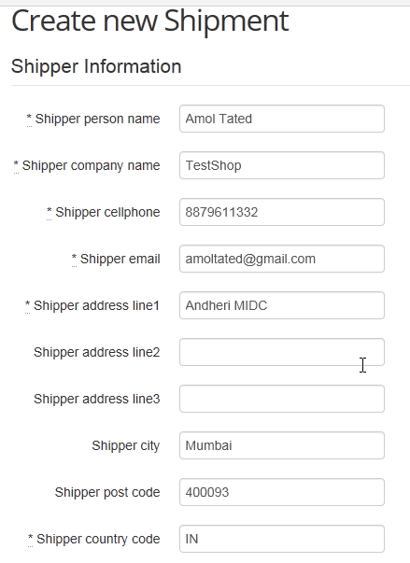
- As for the Consignee information, it will be filled automatically from the Order.
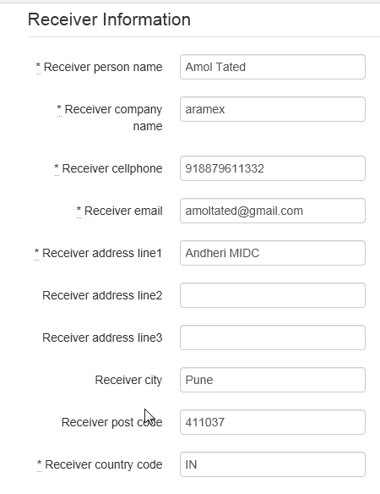
- Fill on the Shipment Details and proceed with the Create Shipment Icon.
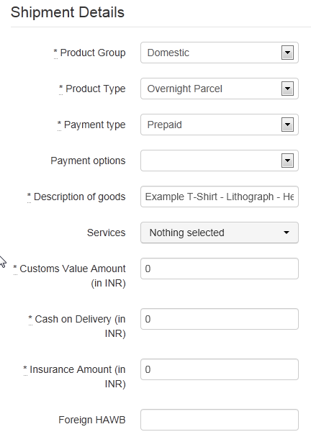

- Users will be able to add attachments to the shipment request if needed.
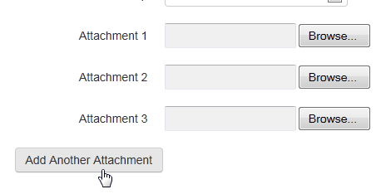
- Click on create shipment button and AWB number will get generate.
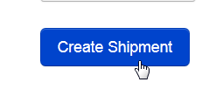
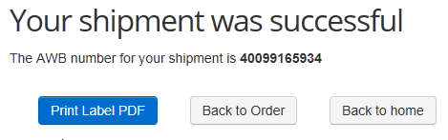

- Print label

- After creating shipment, you can print the label As soon as you created shipment by using Print Label PDF option.
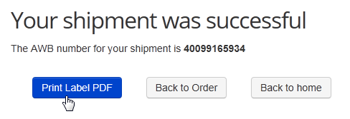
- Another way to view and print the label is by going to the Orders page, for the Fulfilled orders, Users can see the options to either (Print Label or Track Shipment) 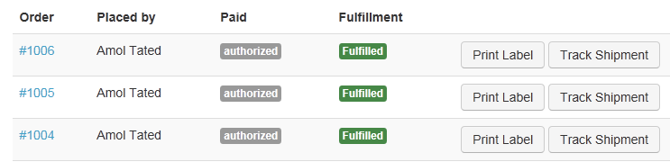
- As shown below, the PDF Label can be viewed and printed:
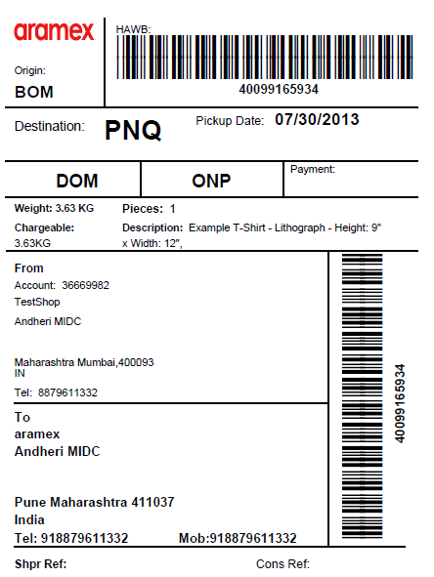
- Track Shipment
- By using this functionality you can track your shipments by clicking on Track Shipment button from the Orders page.
- As shown below, the shipment details will be viewed and get the Shipment Updates.
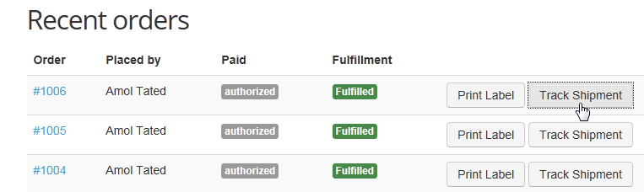
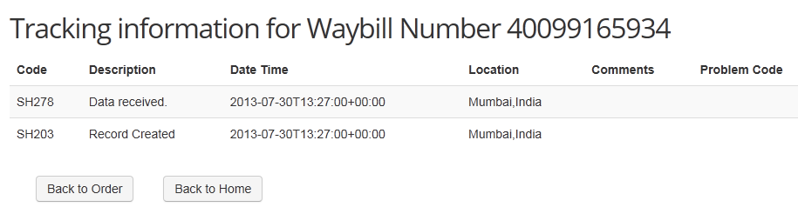

Additional Features
- Updating Account Information: Users can update account details which was saved upon creating the App setup.
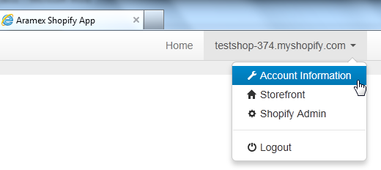
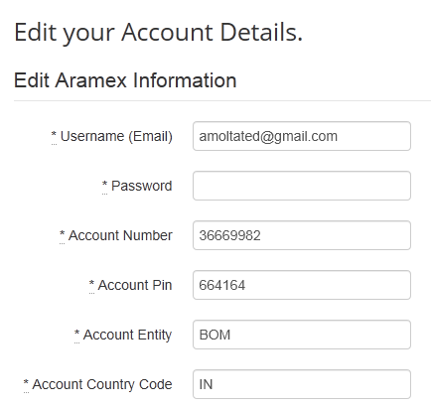
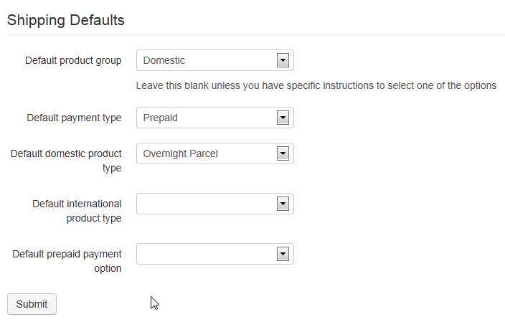

- Search for Orders: You can search order by using order number, and it will get the order information and details.
